**WHAT IS CSS?**

* Cascading Style Sheets
* CSS describes the visual style and presentation of the content written in HTML
* CSS consists of countless properties that developers use to format the content: properties about font, text, spacing, layout, etc.

**How we Select and Style Elements?**

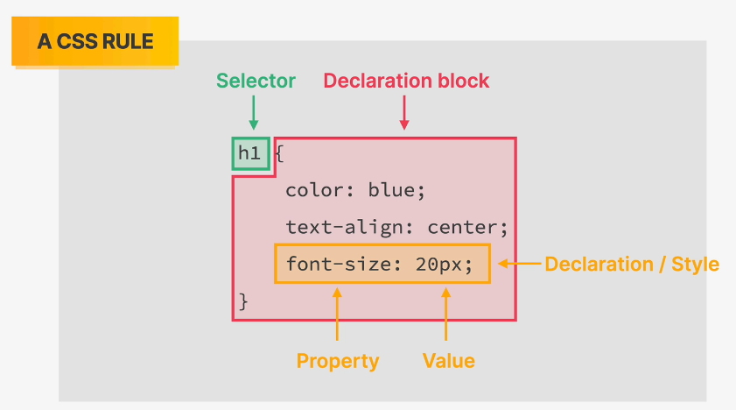

**INLINE STYLE CSS**

 <h1 style="color: blue">The Code Magazine</h1>

**INTERNAL STYLE CSS**

<head>

    <meta charset="UTF-8" />

    <meta name="viewport" content="width=device-width, initial-scale=1.0" />

    <title>Document</title>

    <style>

      h1 {

        color: blue;

      }

    </style>

  </head>

**EXTERNAL STYLE CSS**

Creating an external CSS file and calling the stylesheet into the html:  
 <link rel="stylesheet" href="./style.css" />

**STYLING TEXT**

1. Font-size
2. Font-family
3. Text-transform: capitalization, uppercase, lowercase etc.
4. Font-style: bold, italic etc.
5. Line-height: space between two lines
6. Text-align: alignment of text.